12.26: a) The kinetic energy is
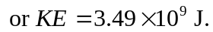

b)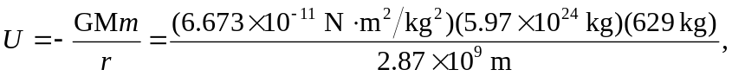

or 